**Week 5: Course Project Part 4**

You will be completing the following components of your Course Project Part 4 deliverables. This deliverable is worth 100 points.

**Earned Value Analysis (20 points)**

Set the project status date to a date that is halfway through your project.

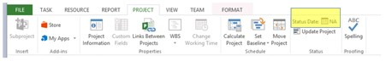

Your project should show the tasks completed as of that date and any cost changes that have occurred. At least 10% of your task should reflect a cost overrun and 5% should come in below budget. You can choose which tasks to modify (10% more, 5% less are approximates). See the following about how to mark task completions. Hover on a task and select Task>Mark on Track (select the drop-down arrow)>Update Tasks.

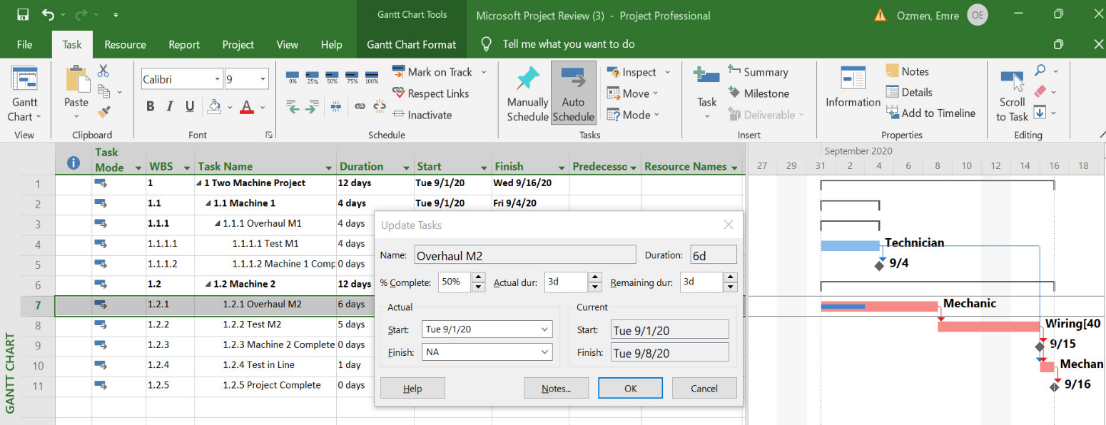

Set the baseline by selecting Project>Set Baseline>Set Baseline>OK>Yes. Then, complete the earned value analysis (EVA) by selecting Reports>Costs>Earned Value Report.

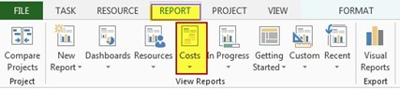

This image is only an example. Results will differ when data is entered.

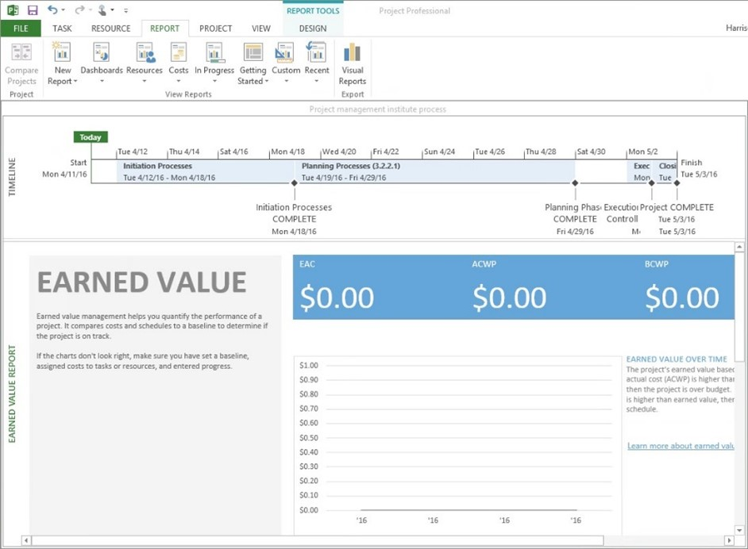

Submit the Earned Value Analysis in either a MS Project file or as a screenshot.

**Project Status Communication (20 points)**

1. Interpret the results of the EVA and write a narrative as a project status communication in an MS Word document. The interpretation of the following calculation is required, which also can be automatically produced with Microsoft Project. This is similar to the previous screenshot by selecting View>Tables>More Tables>Earned Value, as an option.
   1. Earned Value Over Time: BCWS (Planned Value, PV), BCWP (Earned Value, EV), ACWP (Actual Cost, AC)
   2. Variance Over Time (Variance Analysis: SV, CV)
   3. Indices Over Time (Performance Index: SPI, CPI)
2. Submit the Project Status Communication with EVA Interpretation in a one-page Word document.

**Final Course Project Summary (60 points)**

1. The final Course Project Summary should have the following breakdown.
   1. It summarizes the content, as well as the Microsoft Project work, from the entire document with quantifiable highlights, such as overall project cost and schedule performance and estimate to completion, and makes the pitch to project stakeholders to continue the project. This is where you have to act as a project manager and a businessperson. Make sure you utilize references and appendices accordingly. This is worth 25 points.
   2. This section includes a forward-looking estimate of the project completion date and the final project costs based on the performance analysis. It proposes appropriate corrective action(s) that should be taken at this point to put the project back on track based on the Earned Value Management (EVM) performance analysis, as necessary. Make sure you utilize references and appendices accordingly. This is worth 25 points.
   3. The lessons learned section discusses what you would do differently if you were going to do this kind of project again. This is worth 10 points.
2. Submit the Final Course Project Summary in a two- to three-page Word document.